**Day4**

**Java pattern program** enhances the coding skill, logic, and looping concepts. It is mostly asked in **Java interview** to check the logic and thinking of the programmer. We can print a **Java pattern program** in different designs. To learn the pattern program, we must have a deep knowledge of the Java loop, such as **for** loop **do-while** loop. In this section, we will learn **how to print a pattern in Java**.

We have classified the [**Java**](https://www.javatpoint.com/java-tutorial)**pattern program** into three categories:

* **Start Pattern**
* **Number Pattern**

Before moving to the pattern programs, let's see the approach.

Whenever you design logic for a pattern program, first draw that pattern in the blocks, as we have shown in the following image. The figure presents a clear look of the pattern.

Each pattern program has two or more than two loops. The number of the loop depends on the complexity of pattern or logic. The first for loop works for the row and the second loop works for the column. In the pattern programs, [**Java for loop**](https://www.javatpoint.com/java-for-loop) is widely used.

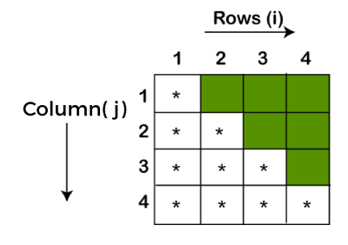

In the above pattern, the **row** is denoted by **i** and the **column** is denoted by **j**. We see that the first row prints only a star. The second-row prints two stars, and so on. The **colored** blocks print the **spaces**.

**Patterns - Part 1**



import java.util.*;

public class Patterns {

   public static void main(String args[]) {

       int n = 5;

       int m = 4;

       for(int i=0; i<n; i++) {

           for(int j=0; j<m; j++) {

               System.out.print("*");

           }

           System.out.println();

       }

   }

}

1. 

import java.util.*;

public class Patterns {

   public static void main(String args[]) {

       int n = 5;

       int m = 4;

       for(int i=0; i<n; i++) {

           for(int j=0; j<m; j++) {

               if(i == 0 || i == n-1 || j == 0 || j == m-1) {

                   System.out.print("*");

               } else {

                   System.out.print(" ");

               }

           }

           System.out.println();

       }

   }

}

1. 

import java.util.*;

public class Patterns {

   public static void main(String args[]) {

       int n = 4;

       for(int i=1; i<=n; i++) {

           for(int j=1; j<=i; j++) {

                   System.out.print("*");

           }

           System.out.println();

       }

   }

}

1. 

import java.util.*;

public class Patterns {

   public static void main(String args[]) {

       int n = 4;

       for(int i=n; i>=1; i--) {

           for(int j=1; j<=i; j++) {

                   System.out.print("*");

           }

           System.out.println();

       }

   }

}



import java.util.*;

public class Patterns {

   public static void main(String args[]) {

       int n = 4;

       for(int i=n; i>=1; i--) {

           for(int j=1; j<i; j++) {

               System.out.print(" ");

           }

           for(int j=0; j<=n-i; j++) {

               System.out.print("*");

           }

           System.out.println();

       }

   }

}

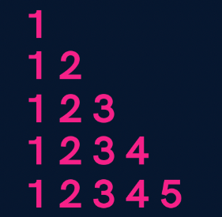

**import java.util.*;**

**public class Patterns {**

**public static void main(String args[]) {**

**int n = 5;**

**for(int i=1; i<=n; i++) {**

**for(int j=1; j<=i; j++) {**

**System.out.print(j);**

**}**

**System.out.println();**

**}**

**}**

**}**

1. 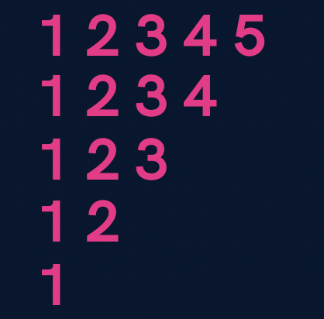

**import java.util.*;**

**public class Patterns {**

**public static void main(String args[]) {**

**int n = 5;**

**for(int i=n; i>=1; i--) {**

**for(int j=1; j<=i; j++) {**

**System.out.print(j);**

**}**

**System.out.println();**

**}**

**}**

**}**